[**Module 7**](https://eclass.srv.ualberta.ca/course/view.php?id=78354&section=8)

## Navigations

Buttons and other navigations like tabs, links, accordions, etc, are essential elements of interface design. They have a primary role in the conversation and interaction between a user and the system.

In our last module, we’ll review some basic principles to create effective buttons and navigations. Watch the video lessons.

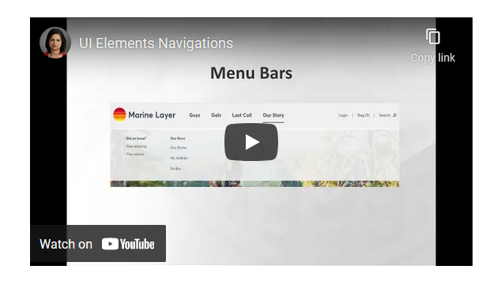

[**https://www.youtube.com/watch?v=gufaMI49aSk**](https://www.youtube.com/watch?v=gufaMI49aSk)

## Buttons

Buttons are one of the most interactive visual elements, they communicate actions that users can take. They are typically placed on dialogues, Forms, Toolbars, etc throughout the UI. Watch the video lesson to learn some basics of creating good Buttons.

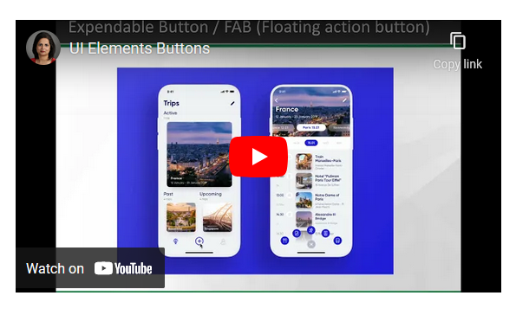

[**https://www.youtube.com/watch?v=jm3UXPBWBC4**](https://www.youtube.com/watch?v=jm3UXPBWBC4)